**DAILY ONLINE ACTIVITIES SUMMARY**

|  |  |  |  |  |  |  |  |  |
| --- | --- | --- | --- | --- | --- | --- | --- | --- |
| **Date:** | **24/06/20** | | | | | **Name:** | **SARANG VK** | |
| **Sem & Sec** | **8th B** | | | | | **USN:** | **4AL16CS085** | |
| **Online Test Summary** | | | | | | | | |
| **Subject** | | **…….** | | | | | | |
| **Max. Marks** | | **……** | | **Score** | | | **……..** | |
| **Certification Course Summary** | | | | | | | | |
| **Course** | **Python for Machine Learning** | | | | | | | |
| **Certificate Provider** | | | **GREATLEARNING** | | **Duration** | | | **28 MINUTES** |
| **Coding Challenges** | | | | | | | | |
| **Problem Statement: Find the smallest positive integer value that cannot be resented as sumof any subset of a given array sorted in ascending order** | | | | | | | | |
| **Status:COMPLETED** | | | | | | | | |
| **Uploaded the report in Github** | | | | | **YES** | | | |
| **If yes Repository name** | | | | | **alvas-education-foundation/sarang_vk** | | | |
| **Uploaded the report in slack** | | | | | **YES** | | | |

Certification Course Details: (Attach the snapshot and briefly write the report for the same)

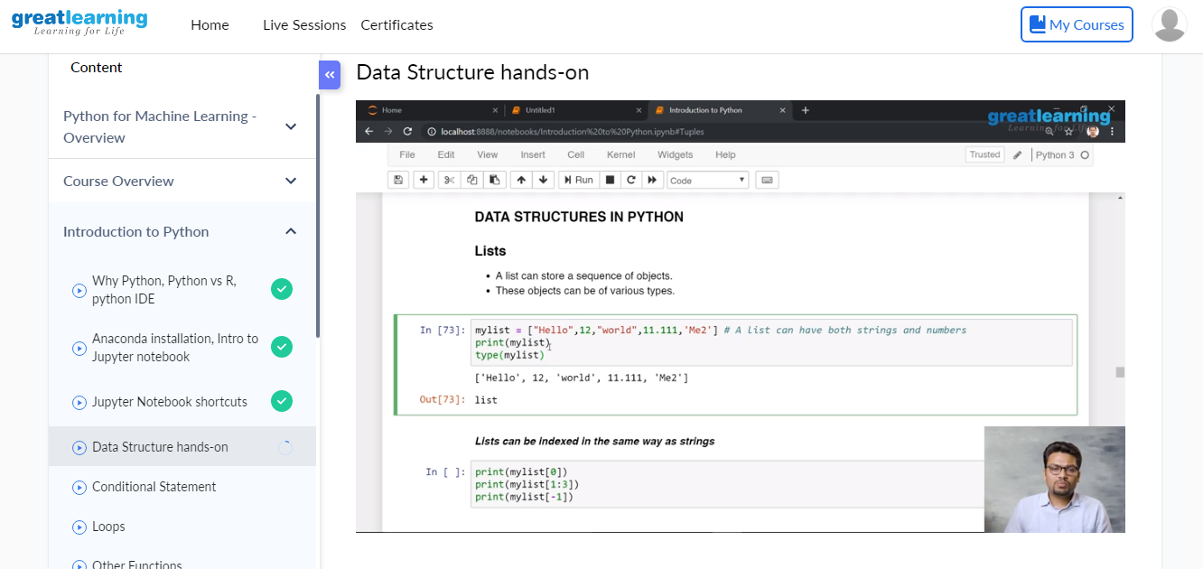

Coding Challenges Details: (Attach the snapshot and briefly write the report for the same)

Coding was given n it was uploaded for github and slack

PROGRAM1

|  |
| --- |
| Find the smallest positive integer value that cannot be resented as sum   of any subset of a given array sorted in ascending order  publicclass  SmallestIntegerInSortedArray {  publicint find(int [] arrA){ |
| intsmlNumber= 1; |
| for(inti= 0;i<arrA.length;i++){ |
| if(arrA[i]<=smlNumber){ |
| smlNumber+=arrA[i]; |
| }else{ |
| break; |
| } |
| } |
| returnsmlNumber; |
| } |
| publicstaticvoid main(String arg[]){ |
| SmallestIntegerInSortedArrayi=newSmallestIntegerInSortedArray(); |
| System.out.println("Smallest Positive Integer that cant be represented by                     the sum of any subset of following arrays are : "); |
| int [] arrA= { 1,1,3,4,6,7,9}; |
| System.out.println("{1,1,3,4,6,7,9} -" +i.find(arrA)); |
| int [] arrB= {1,1,1,1,1}; |
| System.out.println("{1,1,1,1,1} -" +i.find(arrB)); |
| int [] arrC= {2,3,6,7}; |
| System.out.println("{2,3,6,7} -" +i.find(arrC)); |
| int [] arrD= {1,2,6,7,9}; |
| System.out.println("{1,2,6,7,9} -"+i.find(arrD)); |
| } |
| } |